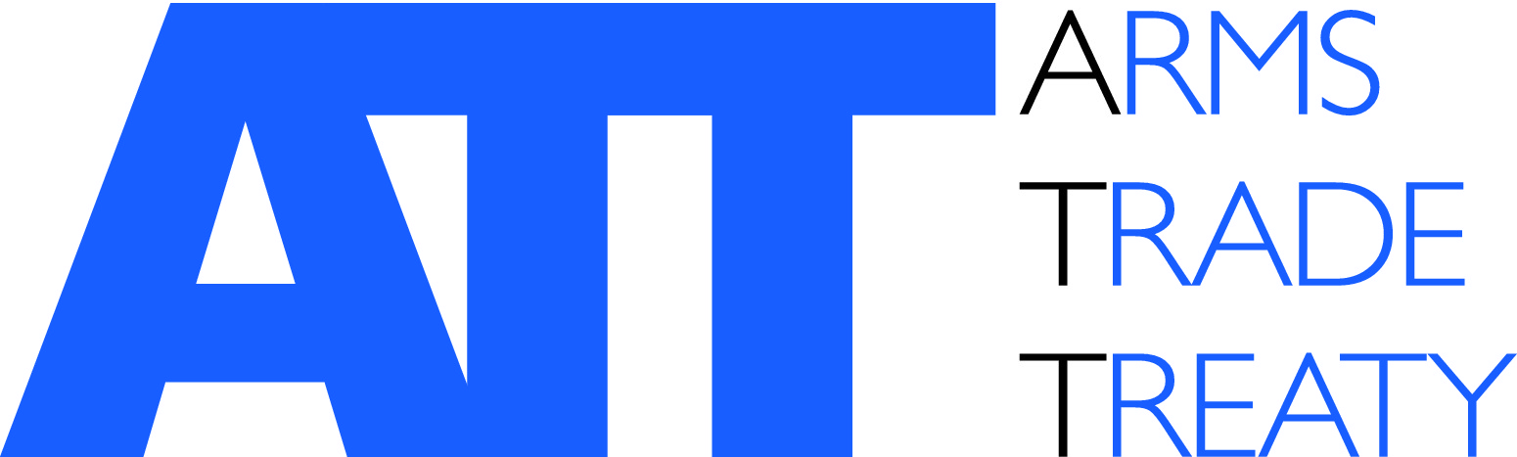 | Issued by the ATT Secretariat

Eleventh Conference of States Parties to the Arms Trade Treaty (CSP11)

SIDE EVENT - PROPOSAL FORM

Monday, 25 – Friday, 29 August 2025

Title: | Title of the side event
Organizer: | Name of the organization(s) and any government(s) hosting the event
Date →:  Room↓: | Monday  25 August | Tuesday  26 August | Wednesday  27 August | Thursday  28 August | Friday  29 August
Room B  (108 persons) |  | Not available
Room C  (108 persons) |  | Not available
Room E
(60 persons)
Room F
(60 persons)
 | Please indicate in the table above the room you would prefer to hold the side-event in. You may select more than one option, if you have flexibility regarding dates.
Speakers: | List the speakers by name in order of appearance
Start time:
Finish time:
Language:
Technical requirements: | Do you require additional audio visual equipment?* Yes No  Please specify:
Interpretation: | Do you intend to provide interpretation?* Yes No
Catering: | Do you intend to provide catering?* Yes No
Address for invoice: | Name and email address of the person the invoice for any additional equipment should be sent to
Focal point: | Name and email address
Description:

*Please note the following:
- Technical requirements: Use of standard audio-visual equipment is charged at CHF 390.- per room. This concerns use of the screen, beamer, microphones and headphones. If you require additional equipment or room configuration, additional costs will be incurred.
- Interpretation: Interpretation equipment is available in all rooms.
- Catering: Catering orders need to be submitted to Eurest by 11 August 2025.

Please submit this form to Mr Tom Nijs, ATT Secretariat, at: tom.nijs@thearmstradetreaty.org by 11 August 2025.

